**Introduction**

The main objective of this laboratory was to get a basic understanding for how feedback control can be used to modify the behaviour of a dynamic system. We will consider P, PI, PD, and PID control of a third order system. We will manually tune the PID values, use algorithmic methods and also the Ziegler Nichols method to generate controller constants and evaluate each method’s performance.

**Effect of P, I, D:**

The purpose of using the Proportional, Integral, and Derivative controllers and their combinations is mainly due to the effects they have on the system to achieve desirable design specifications.

Proportional controllers increase the gain of the output while decreasing the tracking error.

Integral controllers, regardless of their value, would always result in zero steady state tracking error to step input, however, a very high integral gain may make the system unstable.

Derivative controller allows the system to take control action based on the trend in the error signal, though it tends to amplify the noise.

**Problem 1**

a) Step response of the system, found using the step() function:

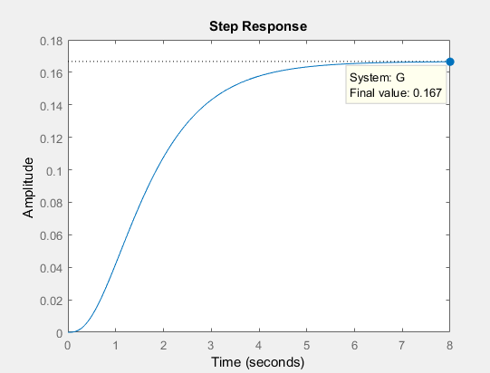

*Step Response of System G - Found in Appendix, Matlab Code*

c) Step response characteristics of the open loop system, found using stepinfo(G):

Steady state value = 0.167

Steady state error = 1 - 0.167 = 0.833

Rise time = 2.7428 s

Settling time = 5.0039 s

Overshoot = 0

d) Root locus of the open loop system, found using rlocus(G):

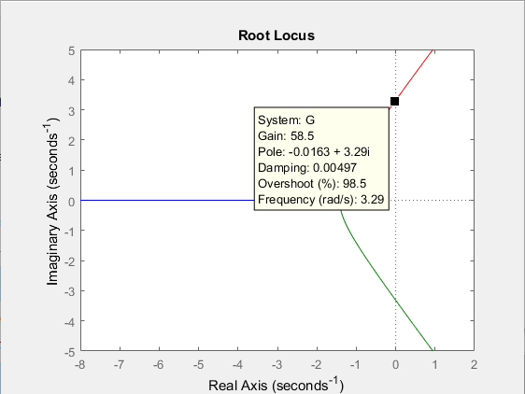

*Root Locus of G, shows Effect of Variable K*

The point on the root loci is -0.0163 + 3.29j, this can be found by clicking on the root locus plot until the point is on the jw axis.

e) Reading from the plot attached above, the gain at the marginal stability can be seen to be: Gain: 58.5

Frequency: 3.29 rad/s

f) Step response, with a proportional controller, see section %% Problem 1 P Controller for steps taken to obtain output:

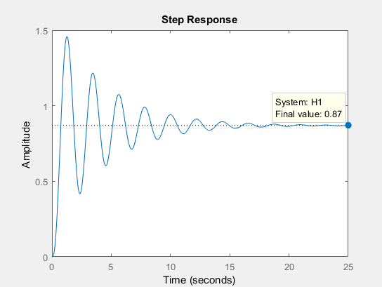

*Step Response of System G with a Proportional Controller Added*

Using the stepinfo function, the settling time of the system is found to be 15.6105 s.

g) Step response characteristics, with a proportional controller:

Steady state error = 0.13

Rise time = 0.4368 s

Settling time = 15.6105 s

Overshoot = 67.6273

Drawbacks of using the proportional controller:

1. Settling time increased

2. There is a large overshoot vs no overshoot for regular system

3. Added oscillation to the system

Benefits of using the proportional controller:

1. Rise time decreased

2. Steady state error also decreased, although not completely eliminated

When compared to the open loop system, the controlled system has

h) Step response, with a proportional derivative controller

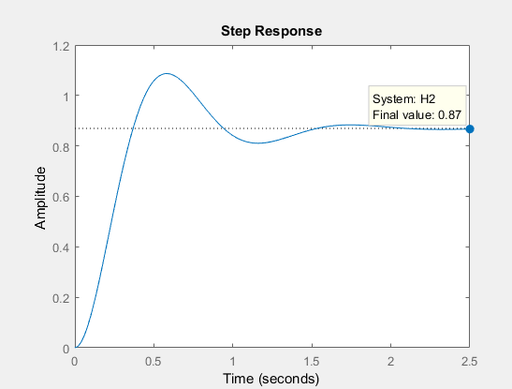

*Step Response of System G with a Proportional Derivative Controller Added*

i) Step response characteristics, with a proportional derivative controller

Steady state error = 0.13

Rise time = 0.2494 s

Settling time = 1.4318 s

Overshoot = 24.9544

Possible improvements with a proportional derivative controller:

1. Steady state error is the same as a regular proportional controller yet improved on the no controller case

2. Overshoot is still high, yet lower relative to proportional control

3. Rise time is improved when compared to a proportional control

Benefits of using a proportional derivative controller:

1. Settling time decreased

2. Rise time decreased

3. Overshoot also decreased

j) Step response, with a proportional integral controller

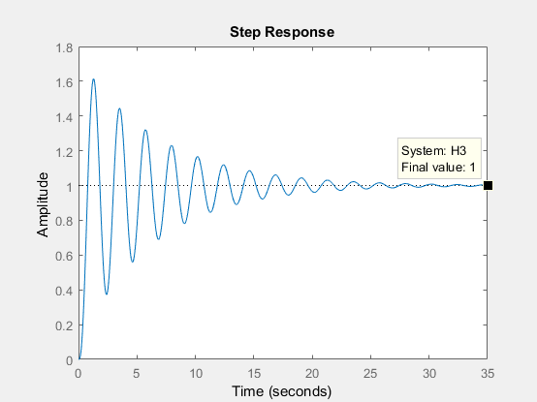

*Step Response of System G with Proportional Integral Controller Added*

k) Step response characteristics with a proportional integral controller:

Steady state error = 0

Rise time = 0.4368 s

Settling time = 23.6832 s

Overshoot = 61.3913

Possible improvements of using the proportional integral controller:

1. Overshoot is almost the same as proportional controller

2. Settling time is much greater than any other controller setup

3. Rise time is the same as proportional controller

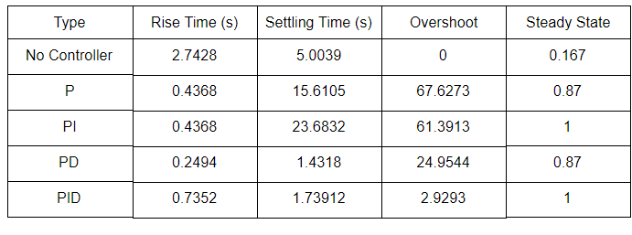

Benefits of using the proportional integral controller:

1. Steady state error reduced to 0

l) No, we can adjust the value of Kp to see its behavior on the system output.

Step response, with a proportional integral controller, Kp = 10, see appendix %% Problem 1 PI Controller:

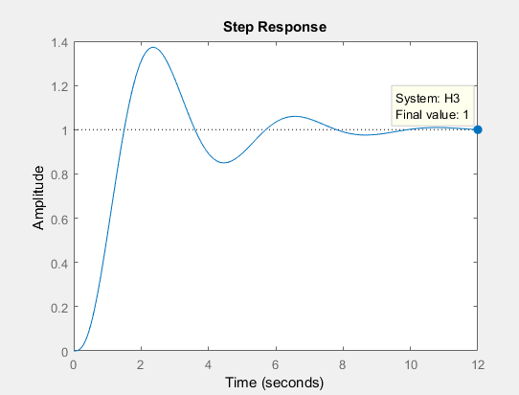

*Step Response of System G with Reduced Proportional Gain and Integral Controller*

Step response characteristics with a proportional integral controller, Kp = 10:

Steady state error = 0

Rise time = 0.9124 s

Settling time = 9.0786 s

Overshoot = 37.2709

Pros of decreasing kp:

1. Overshoot decreases

2. Settling time decreases

Cons of decreasing kp:

1. Rise time increases

m) Step response with a proportional integral derivative controller, see appendix %% Problem 1 PID Controller:

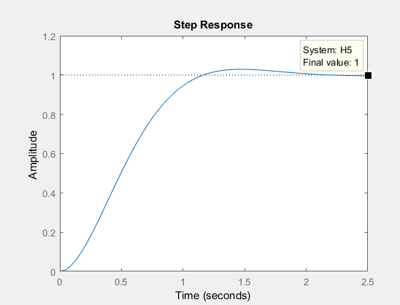

*Step Response of System G with PID Controller Added*

Step response characteristics with a proportional integral derivative controller, using stepinfo():

Steady state error = 0

Rise time = 0.7352 s

Settling time = 1.73912 s

Overshoot = 2.9293

Data table of No Controller, P, PI, PD and PID controllers:

|  |  |  |  |  |
| --- | --- | --- | --- | --- |
| Type | Rise Time (s) | Settling Time (s) | Overshoot | Steady State |
| No Controller | 2.7428 | 5.0039 | 0 | 0.167 |
| P | 0.4368 | 15.6105 | 67.6273 | 0.87 |
| PI | 0.4368 | 23.6832 | 61.3913 | 1 |
| PD | 0.2494 | 1.4318 | 24.9544 | 0.87 |
| PID | 0.7352 | 1.73912 | 2.9293 | 1 |

Comparison of PID with other controllers:

1. Although rise time is highest with respect to other controllers, it is still significantly low

2. Settling time is second to PD controllers, with a difference of 0.30732

3. Overshoot is the least compared to all the controllers

4. Steady State error is 0

**Problem 2**

|  |  |  |  |  |  |  |  |
| --- | --- | --- | --- | --- | --- | --- | --- |
| Type | Disturbance Rejection | Reference Tracking | Balanced | Rise Time (s) | Settling Time (s) | Overshoot | Steady State |
| P | 15.2 | 15.2 | 15.2 | 0.7154 | 5.3911 | 30.2416 | 0.717 |
| I | 1.84 | 1.84 | 1.84 | 4.0235 | 12.7324 | 7.4126 | 1 |
| PI | Kp = 7.59  Ki = 5.03 | Kp = 7.59  Ki = 5.03 | Kp = 7.59  Ki = 5.03 | 1.3383 | 6.0126 | 7.7325 | 1 |
| PD | Kp = 29.9  Kd = 14.8 | Kp = 29.9  Kd = 14.8 | Kp = 29.9  Kd = 14.8 | 0.3756 | 1.9573 | 18.5846 | 0.833 |
| PID | Kp = 12.5  Ki = 9.91  Kd = 3.97 | Kp = 12.5  Ki = 9.91  Kd = 3.97 | Kp = 12.5  Ki = 9.91  Kd = 3.97 | 1.0665 | 2.8508 | 4.5359 | 1 |

**Problem 3**

a) Bode plot of the open loop system

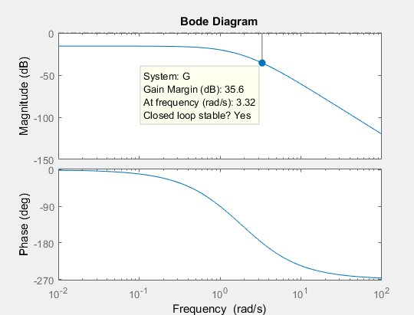

*Step Response of System G - Found in Appendix, Matlab Code*

b) Ultimate gain is found by using the

Ku = 10 ^ (35.6/20) = 60.26

Pu = 2*pi / (3.32) = 1.89

c) The point on the root loci in the first question is -0.0163 + 3.29j. There we got the following values:

Ku = 58.5

Pu = 2*pi / 3.29 = 1.91

The ultimate Gain is lower and the ultimate period is higher in the first question than that of this section, respectively.

d) Controller Values:

Using the values of Table 3 from lab instructions

|  |  |
| --- | --- |
| Type | Optimum Gain |
| P | Kp = 30.13 |
| PI | Kp = 27.12, Ki = 0.62827 |
| PID | Kp = 36.16, Ki =1.047, Kd = 0.2388 |

Step response with PI controller:

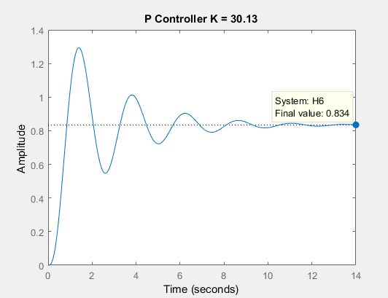

Step response with PI controller

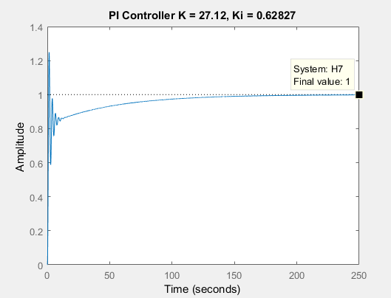

Step response with PID controller

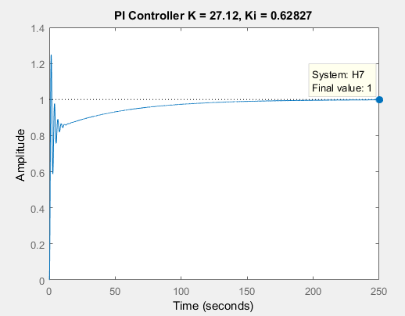

Step response characteristics of P, PI, PID controllers:

|  |  |  |  |  |
| --- | --- | --- | --- | --- |
| Type | Rise Time (s) | Settling Time (s) | Overshoot | Steady State |
| P | 0.5031 | 9.9155 | 55.1110 | 0.834 |
| PI | 0.6209 | 114.2505 | 24.9551 | 1.00 |
| PID | 0.5127 | 77.1730 | 40.3691 | 1.00 |

It is clear to see that the Ziegler Nichols method is an unreliable method to determine an efficient controller schema. The Ziegler Nichols method is primarily used to determine a set of controller characteristics that could be used as a good starting point to perform trial and error analysis.

The Ziegler method returns a set of values that guarantee the system is not unstable, yet may not return the most optimal or efficient result.

**Conclusion:**

It is demonstrated in the lab that a P controller is useful for reducing steady state error and also reduces the rise time, but it ends up increasing the overshoot and settling time. A PI controller reduces the overshoot by a significant amount and reduces the steady state error to zero, while maintaining a low rise time, but it increases the settling time. A PID controller helps reduce the overshoot and settling time, while maintaining a low rise time and a zero steady error.

Tuning a controller algorithmically is much more reliable than when using the Ziegler Nichols method. The Ziegler Nichols method is a good approximation to give controller values that will return a stable system, yet it’s properties are far too general and are not practical in use for designing controllers for specific tasks.

**Appendix**

Gain Table

|  |  |
| --- | --- |
| Ultimate Gain, Problem 1. d) | Ultimate Gain, Problem 3. b) |
| 58.5 | 60.26 |

**Code**

%% Problem 1 a - f

s = tf('s');

G = 1/((s+1)*(s+2)*(s+3));

step(G);

figure;

rlocus(G);

stepinfo(G)

%% Problem 1 P Controller

C_P = pid(40);

open_loop = series(C_P, G);

H1 = feedback(open_loop,1);

hold on;

figure;

step(H1);

stepinfo(H1)

%% Problem 1 PD Controller

C_PD = pid(40,0,30);

open_loop_PD = series(C_PD, G);

H2 = feedback(open_loop_PD,1);

hold on;

figure;

step(H2);

stepinfo(H2)

%% Problem 1 PI Controller

C_PI = pid(10,10,0);

open_loop_PI = series(C_PI, G);

H3 = feedback(open_loop_PI,1);

hold on;

figure;

step(H3);

stepinfo(H3)

%% Problem 1 PID Controller

C_P1 = pid(19,12,8);

open_loop_PID = series(C_P1, G);

H5 = feedback(open_loop_PID,1);

hold on;

figure;

step(H5);

stepinfo(H5)

%% Problem 2 PID Controller Tuning

% opts = pidtuneOptions('DesignFocus','disturbance-rejection');

opts = pidtuneOptions('DesignFocus','reference-tracking');

% opts = pidtuneOptions('DesignFocus','balanced');

% type = 'P';

% type = 'I';

% type = 'PI';

% type = 'PD';

type = 'PID';

C_auto = pidtune(G,type,opts);

open_loop_auto = series(C_auto, G);

H_auto = feedback(open_loop_auto,1);

hold on;

figure;

step(H_auto);

stepinfo(H_auto)

%% Problem 3

bode(G)

%% Problem 3 Zeigler

%% P Controller

C_P1 = pid(30.13, 0, 0);

open_loop_PID = series(C_P1, G);

H6 = feedback(open_loop_PID,1);

step(H6);

title('P Controller K = 30.13');

stepinfo(H6)

%% PI Controller

C_PI1 = pid(27.12, 0.62827, 0);

open_loop_PID = series(C_PI1, G);

H7 = feedback(open_loop_PID,1);

step(H7);

title('PI Controller K = 27.12, Ki = 0.62827');

stepinfo(H7)

%% PID Controller

C_PID1 = pid(36.16, 1.047, 0.2388);

open_loop_PID = series(C_PID1, G);

H8 = feedback(open_loop_PID,1);

step(H8);

title('PID Controller K = 36.16, Ki = 1.047, Kd = 0.2388');

stepinfo(H8)